Lab No. 5 Name: Muhammad Faizan Reg No.21-NTU-CS-1258

# Question No 1

## Input:

#include <iostream>

using namespace std;

int main()

{

int i,sum,marks;

i=1;

sum=0;

do

{

cout<<"Input marks of student "<<i<<": ";

cin>>marks;

sum=sum+marks;

i++;

}while(i<=10);

cout<<"Average is "<<sum/10<<endl;

return 0;

}

## Output:

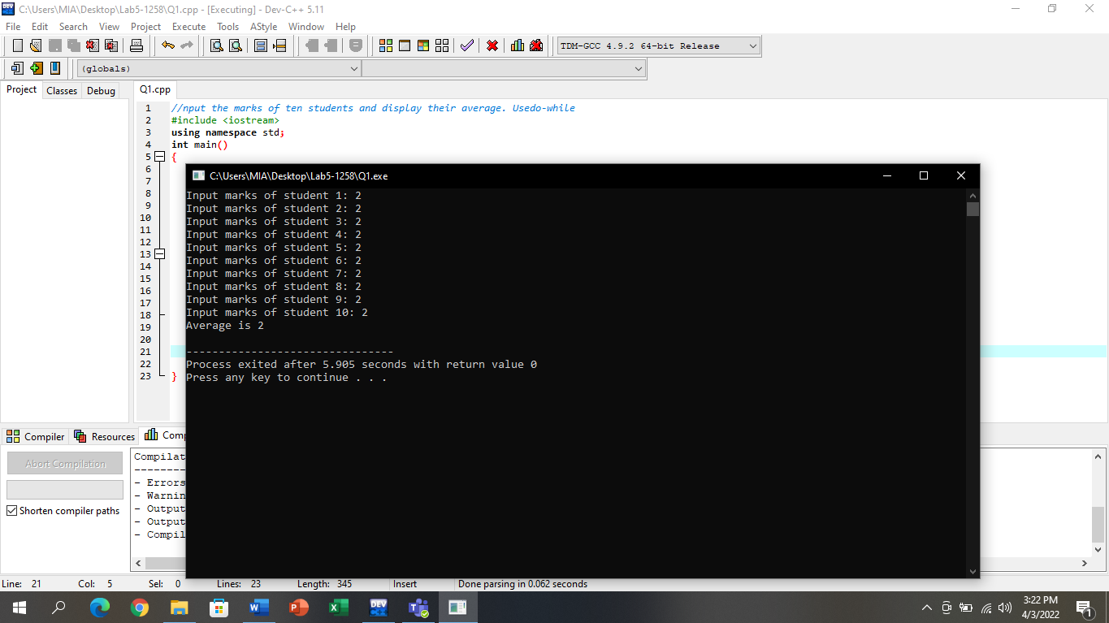

# Question No 2

# (Do-While)

## Input:

#include <iostream>

using namespace std;

int main()

{

char gender;

int i,male,female;

male=0;

female=0;

i=1;

do

{

cout<<"Input Your Gender: ";

cin>>gender;

if((gender=='m')||(gender=='M'))

{

male++;

}

else if((gender=='f')||(gender=='F'))

{

female++;

}

else if(gender!='m' || gender!='M'||gender!='f'||gender!='F')

{

cout<<"Please Enter \'M' or \'m' for male and \'F' or \'f' for female"<<endl;

cout<<"Input Your Gender: ";

cin>>gender;

if(gender=='m'||gender=='M')

{

male++;

}

else if(gender=='f'||gender=='F')

{

female++;

}

}

i++;

}while(i<=10);

cout<<"Number of Male Students: "<<male<<endl;

cout<<"Number of Female Students: "<<female<<endl;

return 0;

}

## Output:

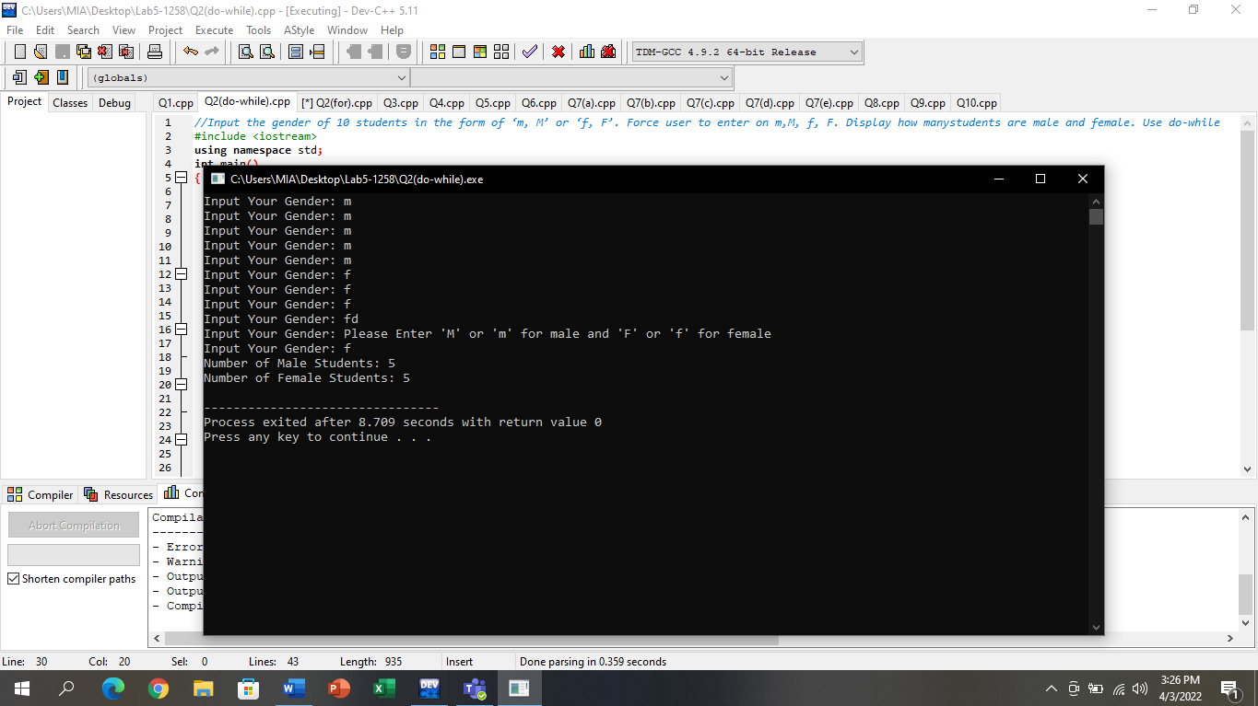

# (For loop)

## Input:

#include <iostream>

using namespace std;

int main()

{

char gender;

int i,male,female;

for(i=1,male=0,female=0;i<=10;i++)

{

cout<<"Input Your Gender: ";

cin>>gender;

if((gender=='m')||(gender=='M'))

{

male++;

}

else if((gender=='f')||(gender=='F'))

{

female++;

}

else if(gender!='m' || gender!='M'||gender!='f'||gender!='F')

{

cout<<"Please Enter \'M' or \'m' for male and \'F' or \'f' for female"<<endl;

cout<<"Input Your Gender: ";

cin>>gender;

if(gender=='m'||gender=='M')

{

male++;

}

else if(gender=='f'||gender=='F')

{

female++;

}

}

}

cout<<"Number of Male Students: "<<male<<endl;

cout<<"Number of Female Students: "<<female<<endl;

return 0;

}

## Output:

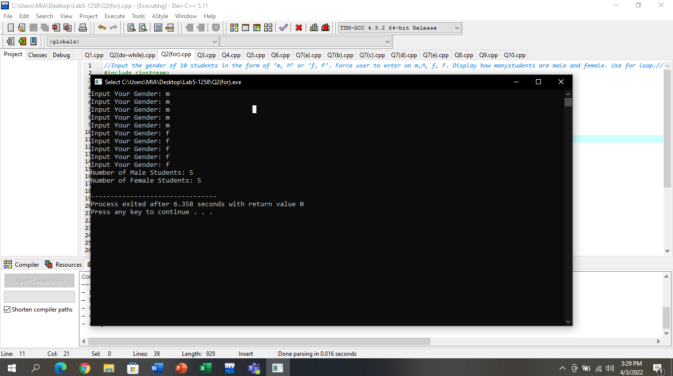

# Question No.3

## Input:

#include <iostream>

using namespace std;

int main()

{

int num_1,num_2;

char c;

cout<<"Enter First Number: ";

cin>>num_1;

cout<<"Enter Second Number: ";

cin>>num_2;

cout<<"Enter Operator(=,-,*,/,% or e for exit) ";

cin>>c;

while(c!='e')

{

switch(c)

{

case '+':

cout<<num_1<<" + "<<num_2<<" = "<<num_1+num_2<<endl;

break;

case '-':

cout<<num_1<<" - "<<num_2<<" = "<<num_1-num_2<<endl;

break;

case '*':

cout<<num_1<<" * "<<num_2<<" = "<<num_1*num_2<<endl;

break;

case '/':

cout<<num_1<<" / "<<num_2<<" = "<<num_1/num_2<<endl;

break;

case '%':

cout<<num_1<<" % "<<num_2<<" = "<<num_1%num_2<<endl;

break;

default:

cout<<"Enter correct operator"<<endl;

break;

}

cout<<"Enter Operator: ";

cin>>c;

}

return 0;

}

## Output:

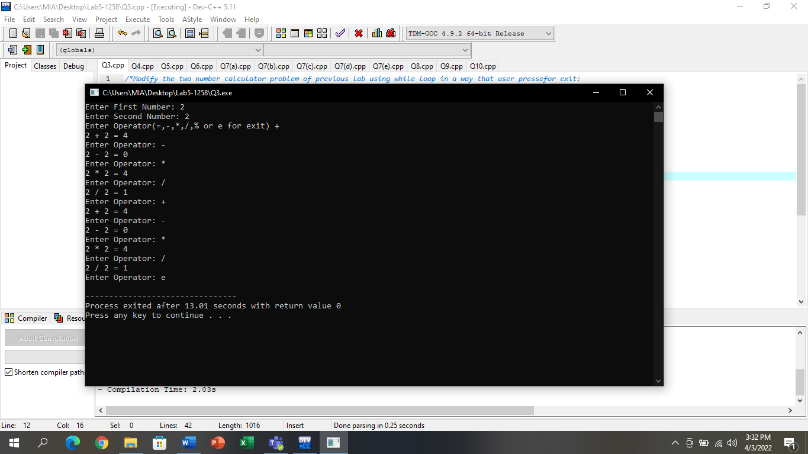

# Question No.4

## Input:

#include <iostream>

using namespace std;

int main()

{

int num;

cout<<"Enter Your number: ";

cin>>num;

while(num!=0)

{

cout<<num%10;

num=num/10;

}

return 0;

}

## Output:

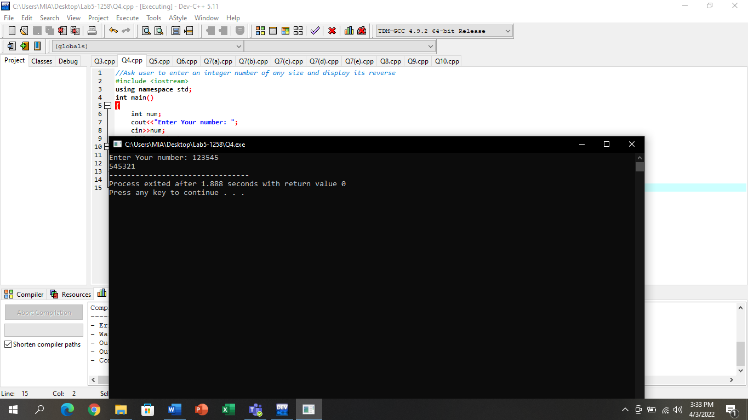

# Question No.5

## Input:

#include <iostream>

using namespace std;

int main()

{

int i,small,large,y;

large=0;

small=999999;

while(i<=10)

{

cout<<"Enter the number ";

cin>>y;

if(y>large)

{

large=y;

}

if(y<small)

{

small=y;

}

i++;

}

cout<<"Large number is "<<large<<endl;

cout<<"Small number is "<<small<<endl;

}

## Output:

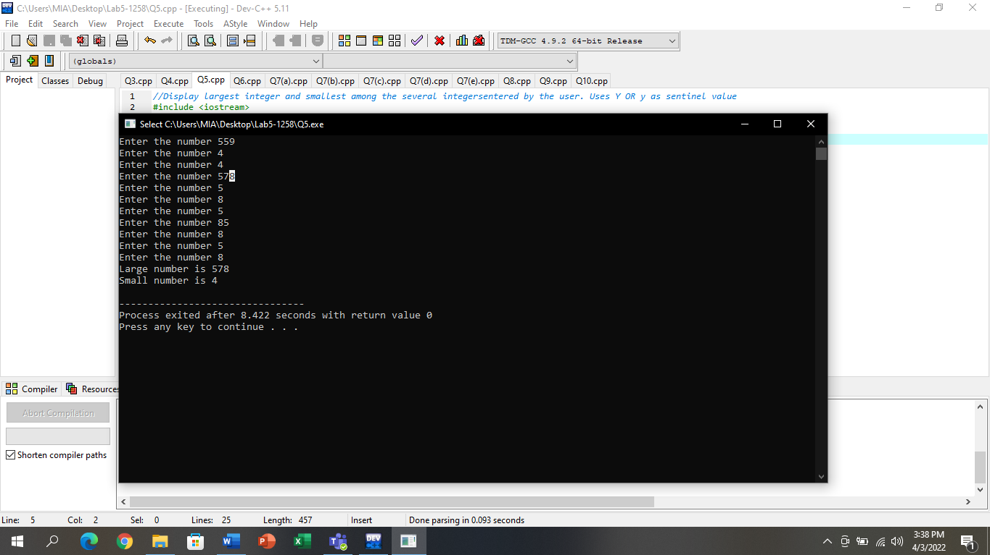

# Question No.6

## Input:

#include <iostream>

using namespace std;

int main()

{

int term_1=0,term_2=1,term_3=2,c;

cout<<"Enter series limit ";

cin>>c;

while(1)

{

term_3=term_1+term_2;

if(term_3>c)

{

break;

}

term_1=term_2;

term_2=term_3;

cout<<","<<term_3;

}

return 0;

}

## Output:

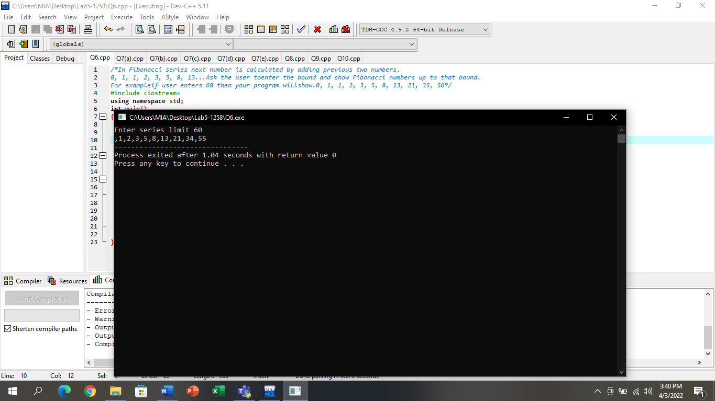

# Question No.7

# (a)

## Input:

#include <iostream>

using namespace std;

int main()

{

int i,j;

i=1;

for(i=1;i<=5;i++)

{

for(j=1;j<=i;j++)

cout<<"*";

cout<<endl;

}

return 0;

}

## Output:

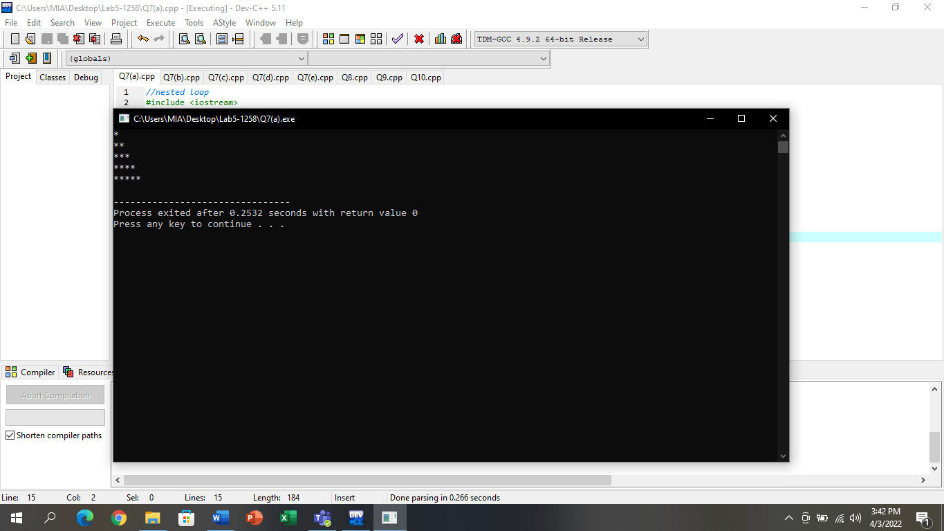

# (b)

## Input:

#include <iostream>

using namespace std;

int main()

{

int i,j;

for(i=5;i>=1;i--)

{

for(j=1;j<=i;j++)

cout<<"*";

cout<<endl;

}

return 0;

}

## Output:

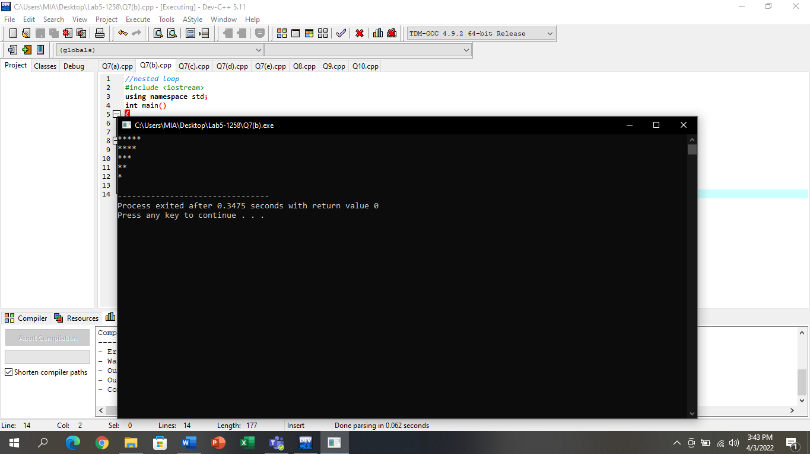

# (c)

## Input:

#include <iostream>

using namespace std;

int main()

{

int i,j;

for(i=5;i>0;i--)

{

for(j=0;j<i;j++)

cout<<"*";

cout<<endl;

}

return 0;

}

## Output:

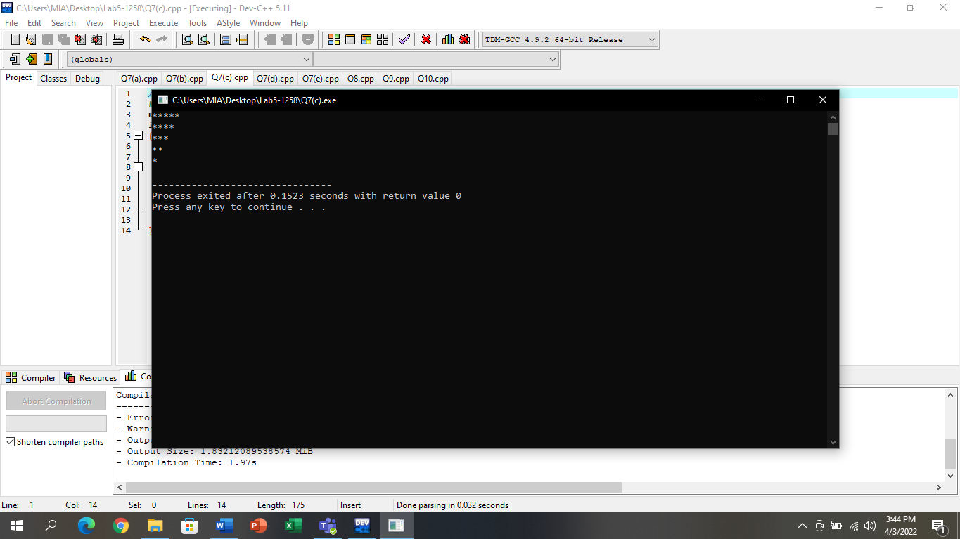

# (d)

## Input:

#include <iostream>

using namespace std;

int main()

{

int i,j;

for(i=0;i<5;i++)

{

for(j=0;j<=i;j++)

cout<<"*";

cout<<endl;

}

return 0;

}

## Output:

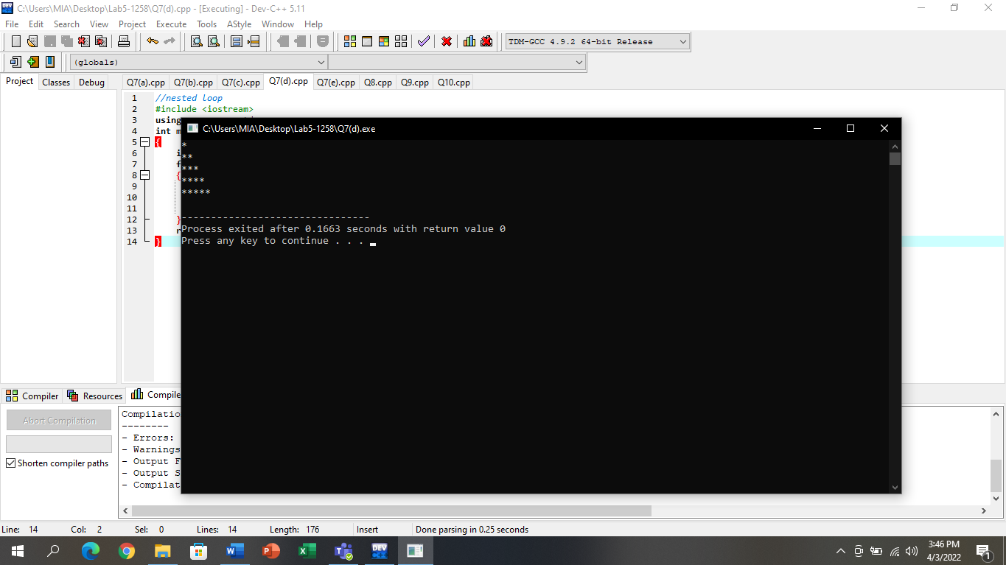

# (e)

## Input:

#include <iostream>

using namespace std;

int main()

{

int i,j;

i=1;

for(i=1;i<=5;i++)

{

for(j=1;j<=i;j++)

cout<<"*";

cout<<endl;

}

cout<<"\n";

for(i=5;i>=1;i--)

{

for(j=1;j<=i;j++)

cout<<"*";

cout<<endl;

}

cout<<"\n";

for(i=5;i>0;i--)

{

for(j=0;j<i;j++)

cout<<"*";

cout<<endl;

}

cout<<"\n";

for(i=0;i<5;i++)

{

for(j=0;j<=i;j++)

cout<<"*";

cout<<endl;

}

return 0;

}

## Output:

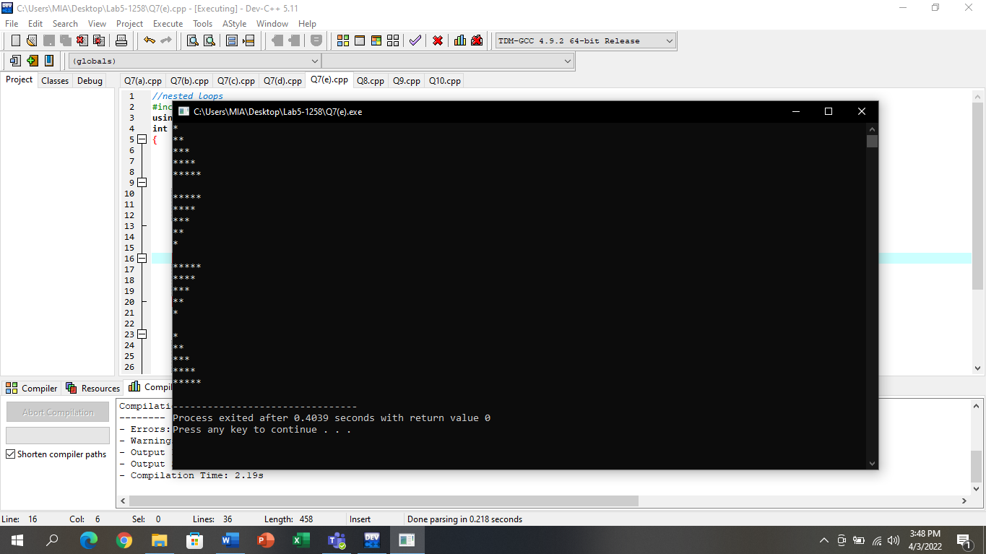

# Question No.8

## Input:

#include <iostream>

using namespace std;

int main()

{

int a,b,c,d,e;

cout<<"Enter Five integers (1 to 20): ";

cin>>a>>b>>c>>d>>e;

for(int i=0;i<a;i++)

{

cout<<"#";

}

cout<<"\n";

for(int i=0;i<b;i++)

{

cout<<"#";

}

cout<<"\n";

for(int i=0;i<c;i++)

{

cout<<"#";

}

cout<<"\n";

for(int i=0;i<d;i++)

{

cout<<"#";

}

cout<<"\n";

for(int i=0;i<e;i++)

{

cout<<"#";

}

cout<<"\n";

}

## Output:

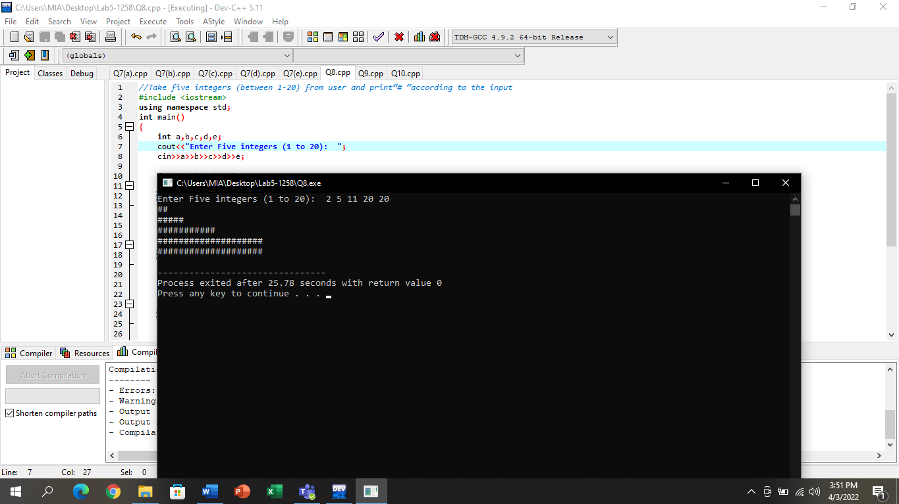

# Question No.9

## Input:

#include<iostream>

using namespace std;

int main()

{

int i,j;

for(i=1;i<=5;i++)

{

for(j=1;j<=i;j++)

cout<<i*j<<" ";

cout<<"\n";

}

return 0;

}

## Output:

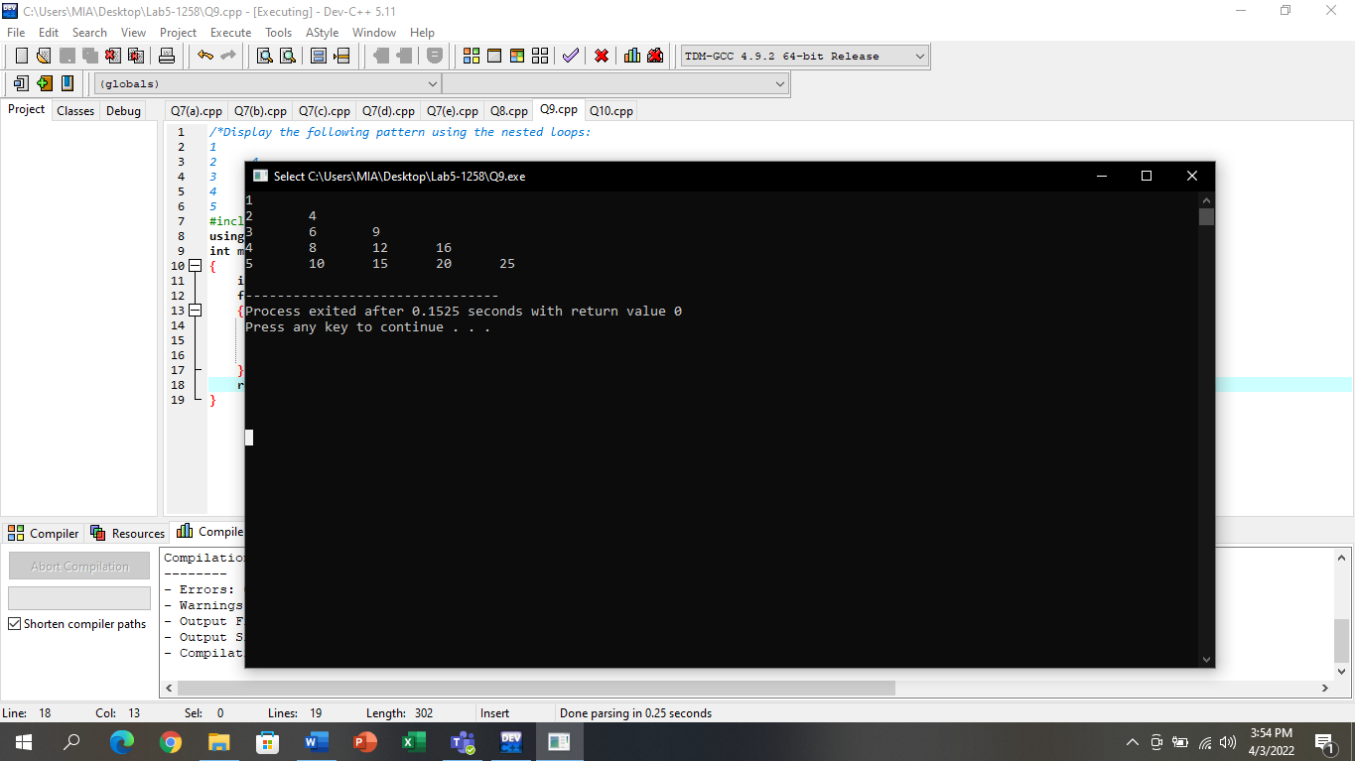

# Question No.10

## Input:

#include <iostream>

using namespace std;

void multi();

void dollar();

void state();

int main()

{

multi();

cout<<endl;

dollar();

cout<<endl;

state();

cout<<endl;

}

void multi()

{

for(int i=0;i<=20;i++)

cout<<"*";

}

void dollar()

{

for(int i=0;i<=20;i++)

cout<<"$";

}

void state()

{

for(int i=0;i<=20;i++)

cout<<"@";

}

## Output:

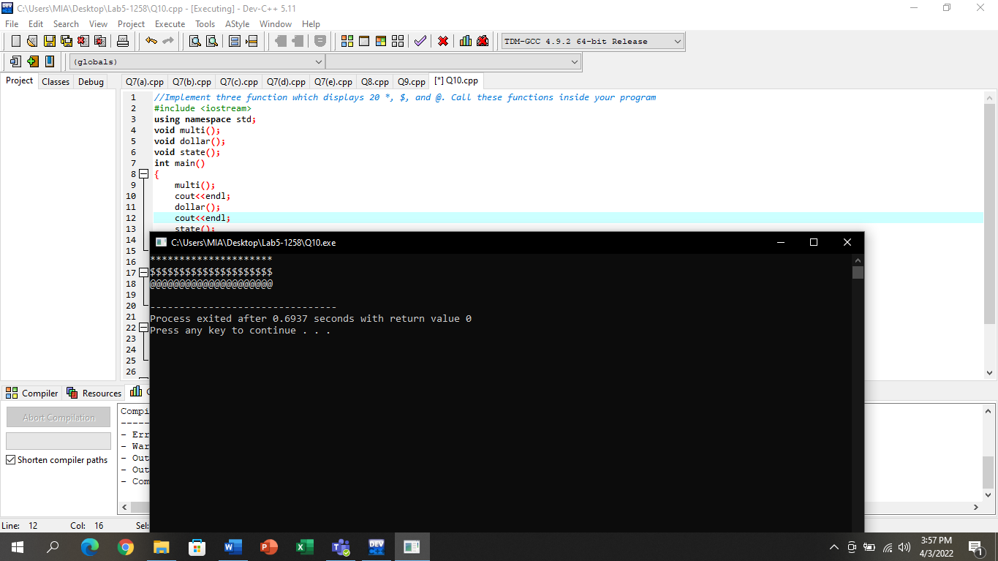

# Question No.11

## Input:

#include <iostream>

using namespace std;

void check();

int main()

{

check();

cout<<endl;

}

void check()

{

int num,max=0,min=100000;

for (int i=1;i<=5;i++)

{

cout<<"Enter the number ";

cin>>num;

if(num>max)

max=num;

if(num<min)

min=num;

}

cout<<"Maximum Number is: "<<max<<endl;

cout<<"Minimum Number is: "<<min;

}

## Output:

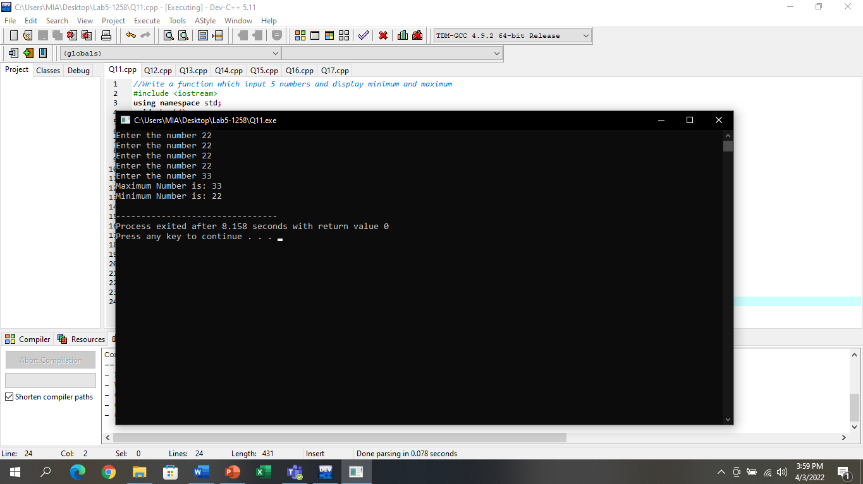

# Question No.12

## Input:

#include <iostream>

using namespace std;

void average();

int main()

{

average();

cout<<endl;

}

void average()

{

int avg,a,b,c,d,e;

cout<<"Input Five integers: ";

cin>>a>>b>>c>>d>>e;

avg=(a+b+c+d+e)/5;

cout<<"Average is "<<avg;

}

## Output:

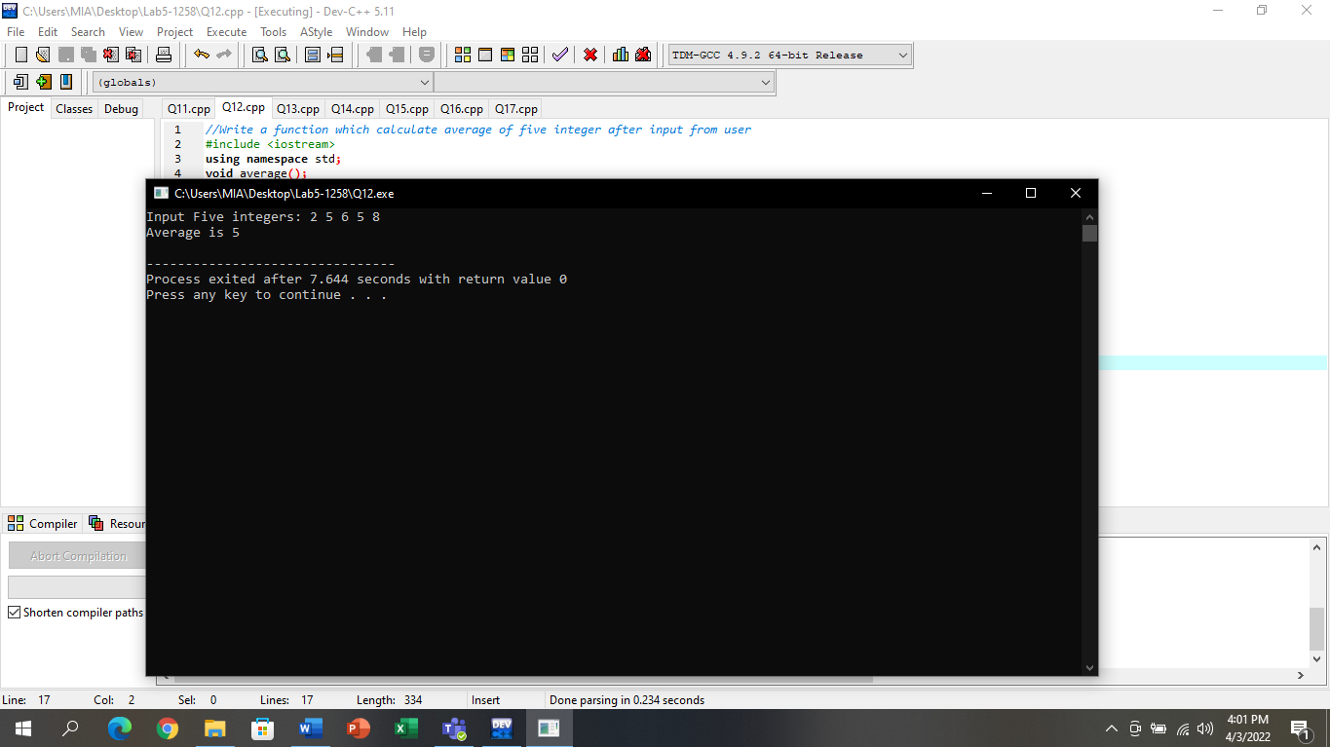

# Question No.13

## Input:

#include <iostream>

using namespace std;

void hash();

int main()

{

hash();

return 0;

}

void hash()

{

for(int i=1;i<=10;i++)

{

for(int j=1;j<=i;j++)

{

cout<<"#";

}

cout<<endl;

}

}

## Output:

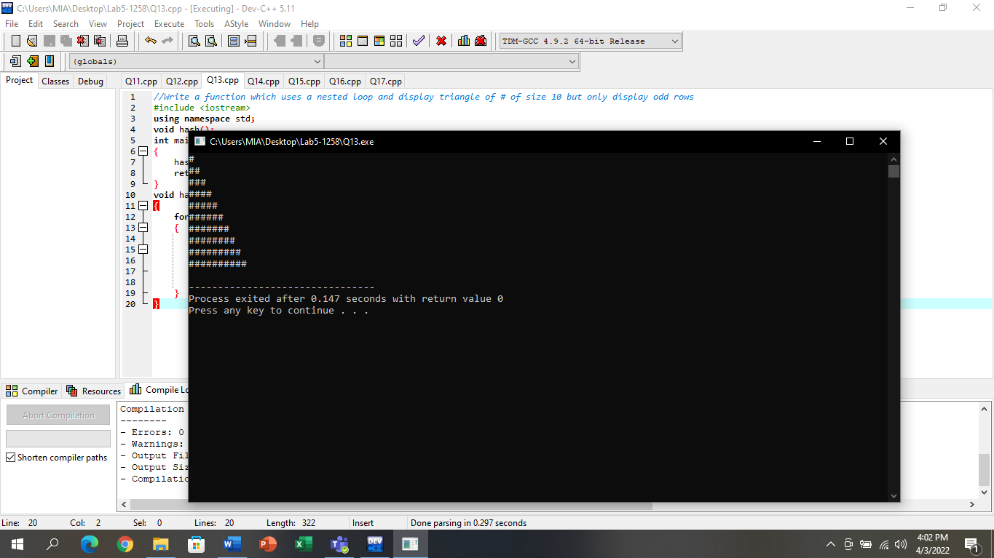

# Question No.14

## Input:

#include <iostream>

using namespace std;

void evenorodd();

int main()

{

evenorodd();

return 0;

}

void evenorodd()

{

int num;

cout<<"Enter the number: ";

cin>>num;

if(num%2==0)

cout<<"The given number is Even"<<endl;

else

cout<<"The given number is Odd";

}

## Output:

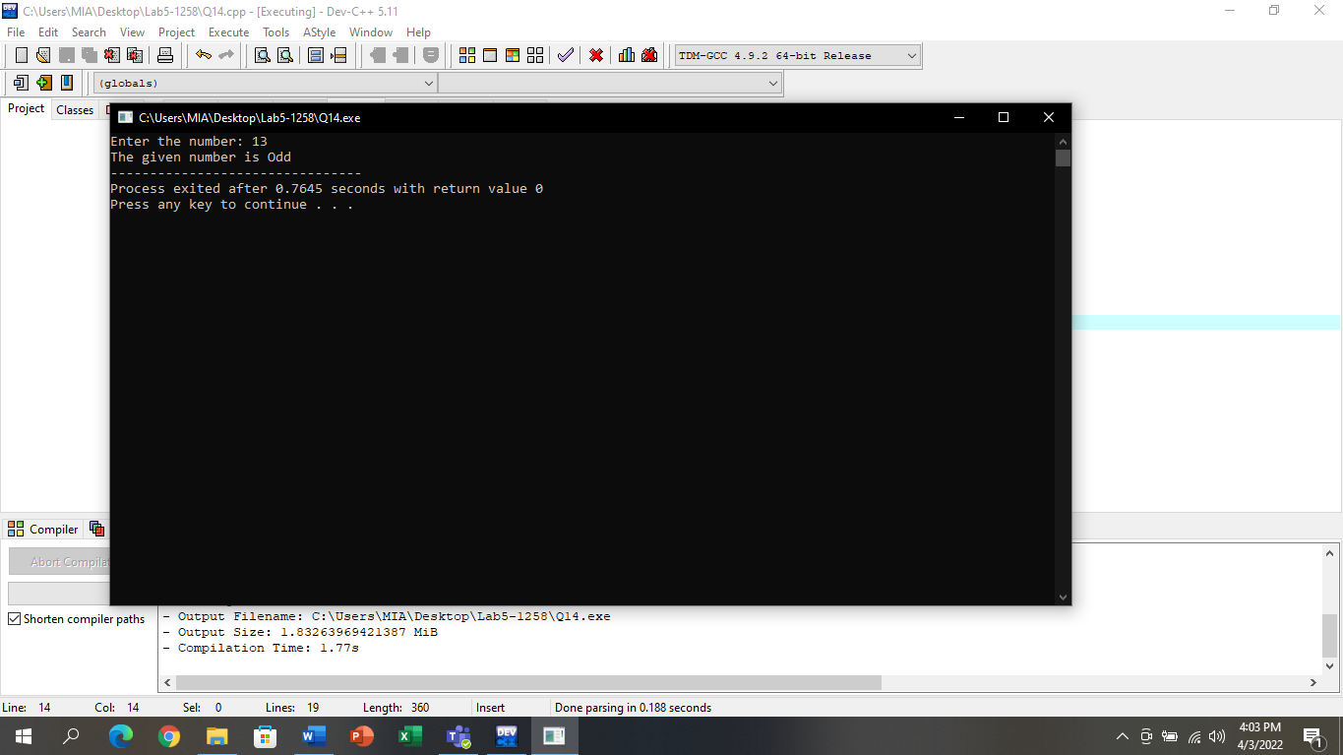

# Question No.15

## Input:

#include <iostream>

using namespace std;

void tenspace();

int main()

{

tenspace();

return 0;

}

void tenspace()

{

cout<<".";

for(int i=1;i<=10;i++)

{

cout<<" ";

}

cout<<".";

}

## Output:

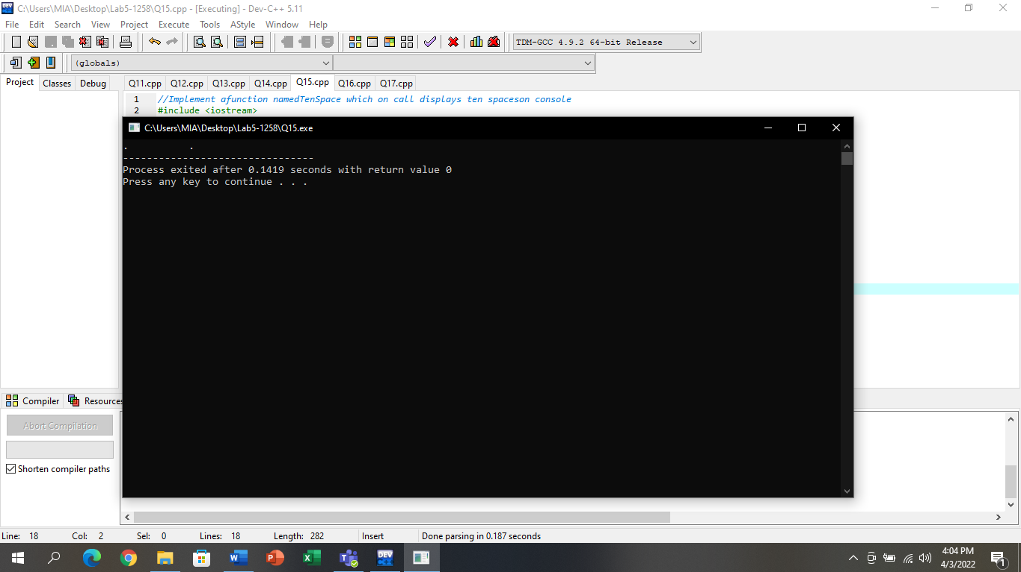

# Question No.16

## Input:

#include<iostream>

using namespace std;

void asterisks();

int main()

{

asterisks();

asterisks();

asterisks();

asterisks();

asterisks();

}

void asterisks()

{

for (int i=1;i<=10;i++)

{

for (int j=1;j<=i;j++)

{

cout<<"*";

}

cout<<endl;

}

}

## Output:

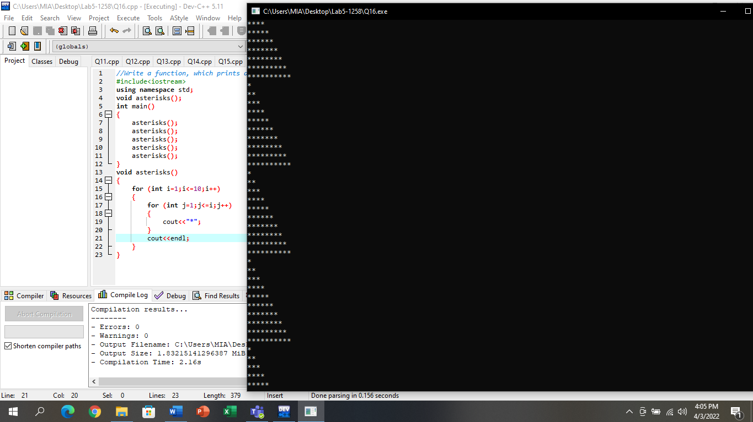

# Question No.17

## Input:

#include<iostream>

using namespace std;

void encrypt();

void decrypt();

int main()

{

encrypt();

cout<<endl;

decrypt();

cout<<endl;

return 0;

}

void encrypt()

{

int first,second,third,forth,num;

cout<<"Enter four digit number: ";

cin>>num;

do

{

cout<<"Encrypt the four digit: ";

cin>>num;

if(num>9999||num<1000)

{

cout<<"\nInvalid Digit\nEnter Four Digit Number"<<endl;

}

else

{

break;

}

}

while(1);

forth=num%10;

num=num%10;

third=num%10;

num=num%10;

second=num%10;

num=num%10;

first=num%10;

num=num%10;

cout<<"Encrypt the number "<<first<<second<<third<<forth<<endl;

}

void decrypt()

{

int first,second,third,forth,num;

cout<<"Enter four digit number: ";

cin>>num;

do

{

cout<<"Decrypt the four digit: ";

cin>>num;

if(num>9999||num<1000)

{

cout<<"\nInvalid Digit\nEnter Four Digit Number"<<endl;

}

else

{

break;

}

}

while(1);

forth=num%10;

num=num%10;

third=num%10;

num=num%10;

second=num%10;

num=num%10;

first=num%10;

num=num%10;

cout<<"Decrypt the number "<<first<<second<<third<<forth<<endl;

}

## Output:

